
THE G8 EXAMINATION
Kenya Certificate of Secondary Education
FORM 4 TERM 2- JUNE 2026

312/1 GEOGRAPHY
PAPER 1
TIME: 2 HOURS 45 MINUTES

MARKING SCHEEME

SECTION A: Answer ALL questions in this section.
1(a)Define the term weather. (2marks)
- It is the atmospheric condition of a given place over a given period of time
b) State three ways through which air rises to form rainfall rise. (3marks)
- When winds blow over a mountainous region
- When hot air rises by convectional currents
- When warm air rises over cold air
2.a) Give two examples of intrusive igneous rocks. (2marks)
- Granite
- Gabbro
- Diorite
- Peridotite
- Porphyry
- Dolerite
b) State three characteristics of sedimentary rocks. (3marks)
- They are found in layers/stratified
- Some are made from sediments
- They are multi coloured/many colours
- Some contains fossils
- They can either mechanically,chemically or organically formed
- They are non- crystalline.

3.Describe the continental drift theory. (5marks)
- The theory states that earth was originally one huge landmass called pangea meaning super continent.
- Pangea was surrounded by a great ocean called Panthalassa.
- Due to different gravitational forces, Pangaea broke up into two landmasses namely Laurasia to the north and Gondwanaland to the south.
- Laurasia and Gondwanaland were separated by a fairly narrow sea called Tethys (the present Mediterranean Sea).
- Further split occurred on the two landmasses.
- Laurasia broke to form the continents in the northern hemisphere namely Europe, North America and Asia.
- Gondwanaland broke to form the continents in the southern hemisphere namely Africa, south America, Australia and Antarctica.
4.a) Name two fresh fault lakes in Kenya (2marks)
- Lake Baringo
- Lake Naivasha

b) State three characteristics of lakes formed through faulting (3marks)
- Most are narrow
- They are steep-sided
- Most are deep/ some are shallow
- Most of them are salty/ some are fresh
- Most of them are long
- Most lack outlets
5. The diagram below represents some features formed in Karst landscape.
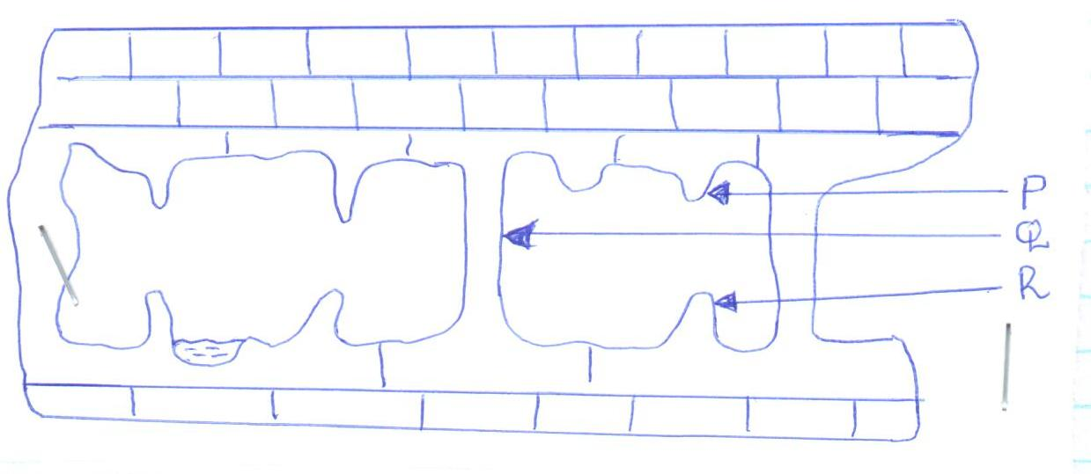
    - State the features labelled P, Q and R. (3marks)
P - Stalactite.
Q – Limestone Pillar
R – Stalagmite.
    - State two conditions for the formation of an artesian well / basin. (2marks)
- The aquifer must be exposed in an area of sufficient precipitation/ water source to provide more water into the well preventing it from drying.
- The aquifer must be sandwiched/ lie between two impermeable rock layers so that it can retain water.
- The mouth of the well must be lower than the intake area to ensure water has sufficient pressure to flow out naturally.
- The rock structure must form a shallow syncline such that the mouth of the well is at a lower level to ensure sufficient pressure to naturally force out water.
- The margins of the aquifer must be exposed to allow water to infiltrate.
- There must be a partial or total blockage of exit for the water to be replaced under pressure.
- The aquifer must be of the same permeable materials so as to retain water.

SECTION B:Answer question 6 and any other TWO questions from this section.
6. Study the map of KIPKABUS 1:50,000 (sheet 104/1) provided and answer the following questions. (a)(i) What is the magnetic variation of the area covered. (2marks)
2⁰8’
(ii) Identify three physical features in grid square 8237. (3marks)
- River valley
- River
- Seasonal swamp
- Vegetation/ scattered trees

(iii)Convert the ratio scale on the map to a statement scale (2marks)
RF = 1:50000
1km = 100,000cm
50000cm/100,000cm =0.5
Therefore, statement scale = 1cm represent ½ km / 0.5km
b) Describe distribution of natural vegetation in the area covered by the map (5marks)
- There is woodland vegetation in the western part/ grid square 8335.
- There is scrub vegetation in the Northern/ Eastern part of the area covered by the map.
- There are scattered trees in the Northern/ Eastern part of the area covered by the map.
- There is papyrus swamp vegetation in the Western part.
- There is Tingwa Hill forest in the Southern part/ Kipkabus forest in the Southern/ Western part.
- There is thicket vegetation in the Southern part.
- There is bamboo vegetation in the Western part/ grid square 8336.
Any 5x1= 5marks
c) Using a scale of 1cm to represent 20 metres draw a cross section along Northing 40 to the west of Easting 84
(4marks) On the cross section mark and label the following
-river (1mark)
-Plantation (1mark)
-District boundary (1mark)
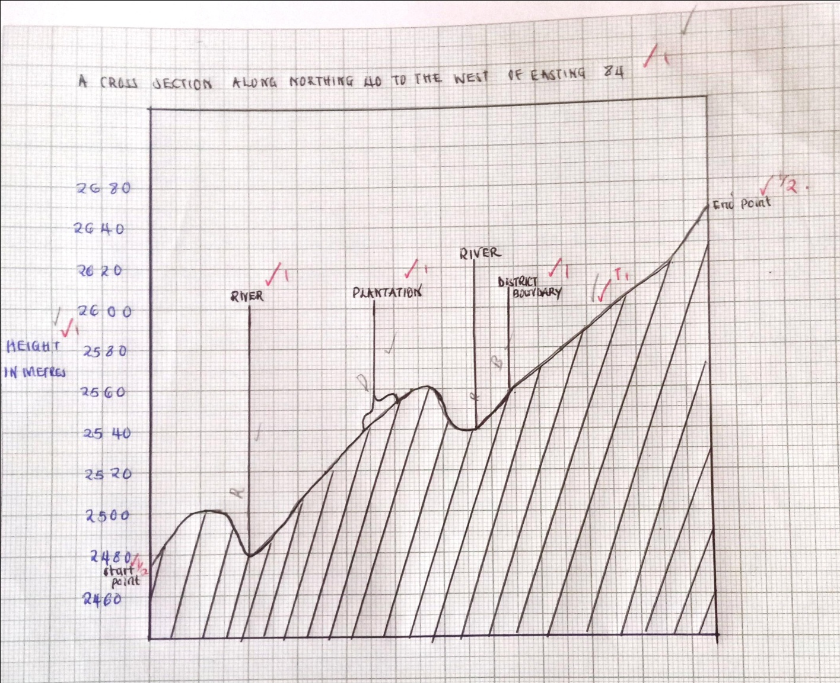
d) Citing evidence from the map state three economic activities carried out in the area covered by the map.
(6marks)
- TransportationA evidenced by roadsE / railway lines.
- TradingA evidenced by shops. E
- ProcessingA / milling/ lumbering evidenced by saw millsE / mills.
- Wattle cultivationA evidenced by wattle plantation.E
- ForestryA evidenced by forests/ forests centre. E
- CommunicationA evidenced by post office. E
(Activity -MAX 3 Evidence -MAX 3) =6marks
7.a(i) What is faulting (2marks)
Faulting is a process of fracturing/ breaking/ cracking of crustal rocks due to tectonic forces.
(ii) Give three types of faults (3marks)
- Normal fault
- Reverse fault
- Shear/Tear fault
- Thrust fault
- Anticlinal fault

b(i) Apart from rift valley list three features formed as a result of faulting (3marks)
- Fault scarp/Scarp slope/Escarpment
- Fault steps
- Tilt block
- Block Mt/ Horst Mt/ Fault block
- Depression/ Rift valley lakes.
(ii)Using well labeled diagrams, describe formation of Rift valley by tensional forces. (8marks)
Layers of rocks are subjected to tensional forces when there is some instability within the earth’s crust.

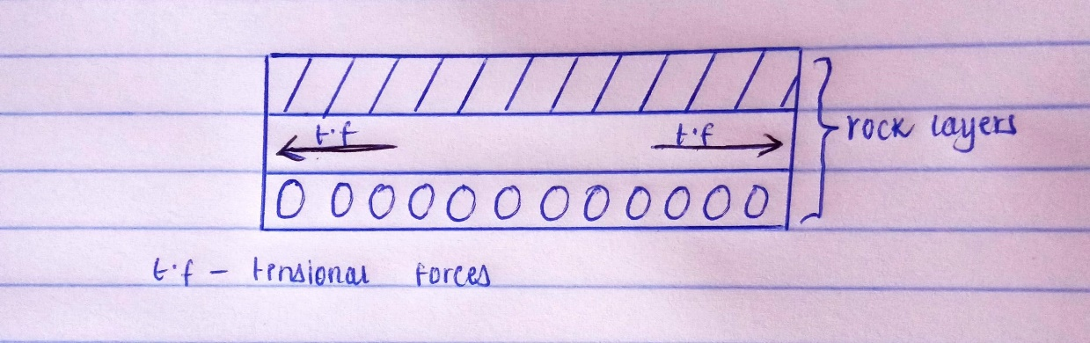
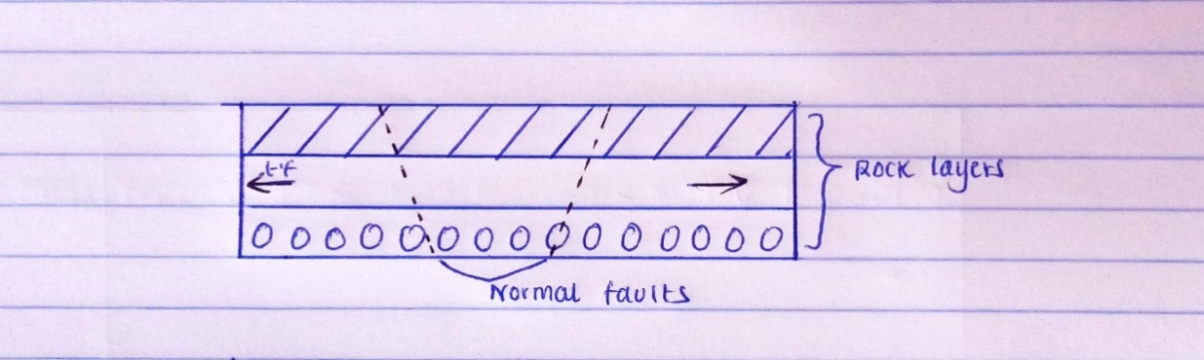
Parallel /adjacent lines of weakness/normal faults develop

With time, the middle part sinks/subside as the side blocks are pulled apart.The sunken middle part forms a depression/trough known as the Rift Valley.

(Diagram 4marks Text 4marks = 8marks)
c) Explain two ways in which faulting influences drainage (4marks)
- Uplift of the landscape/ back tilting may cause rivers to reverse their direction of flow.
- Vertical faulting across a river may cause a change in the base level resulting in the formation of a waterfall.
- Faulting can cause a river to flow along its fault lines leading to formation of fault-guided drainage pattern.
- Some rivers may disappear into the ground through a fault forming underground streams.
- Faulting may expose underground water leading to formation of springs.
- Basins/depressions resulting from faulting may be filled with water to form lakes.
- Uplift of some parts of the river channel may cause river rejuvenation.
d (i) Give three natural causes of earthquakes (3marks)
- Collision of tectonic plates.
- Movement of magma within the earth’s crust/volcanic eruption
- Gravitative pressure
- Isostatic adjustment
- Energy released from the mantle
(ii)Name two major earthquake zones of the world (2marks)
- The Circum-pacific belt/Ring of fire.
- The Mediterranean- Himalayan belt.
- The Great Rift Valley belt.
- Mid-Atlantic ocean belt
8 (a) (i) Differentiate between natural and semi natural vegetation. (2marks)

- Natural vegetation refers to vegetation that develops without interference and modification by human activity while semi natural vegetation refers to vegetation that is in the process of recovering from human disturbance but it’s yet to reach a new climax.
( both statements must be correct to score)

(ii) State two reasons why the mountain top has no vegetation. (2marks)

- The temperatures are too low to support plant growth.
- There is no soil to support plants / bare rock / rocky / rocks.
- Water is always in a frozen state / ice / snow.
b)i) Name the temperature grassland found in the following countries.
- Canada- prairies. (1mark)
- Russia - steppes. (1mark)
- Australia -downs (1mark)
(ii) Describe the characteristics of the savannah vegetation. (5marks)
- Savanna vegetation is a mixture of trees and grass.
- The dominant type of vegetation is grass.
- In the wetter areas, the vegetation consists of tall scattered trees/ woodland.
- The wetter areas have a continuous cover of long thick grass.
- In the drier areas, trees are shorter, fewer and scattered.
- In the drier areas, grass is short and course/ tufts.
- Most of the trees have umbrella shaped crown.
- Most of the trees are deciduous/ shed their leaves.
- Most trees are acacia.
- Along the river valleys, there are tall trees/thick bushes.
- Dominant grass species are elephant grass/ kikuyu grass/ cloves / the red oat.
- Some trees have long tap roots.
- Some trees have small/ waxy/ shiny/ thin
(c) Explain three ways in which desert vegetation adapts to climatic conditions. (6marks)

- Some plants have thick/fleshy/succulent leaves/barks to enable them store water.
- Some plants have long roots to tap the underground water.
- Some have no leaves/have thin/spiky/waxy/needle like leaves to reduce transpiration.
- Some plant seeds remain dormant awaiting the short rains.
- Some plants have thick/hard barks to reduce transpiration.
- Some plants have thorns to protect themselves from browsing animals.
- Some plants have underground bulbs to store water.
- Most plants are stunted /dwarf like due to the harsh conditions.
- Some plants are quick sprouting to take advantage of the short-lived desert rains.
Nb ( Double tick at the end)
d)You are planning to carry out a field study of the vegetation within the local environment.
(i)State three preparations you will make for the field study. (3 marks)
- Formulate objectives/hypotheses for the study.
- Carry out reconnaissance of the area of study.
- Seek permission from the relevant authorities.
- Acquire appropriate stationery/tools/equipment.
- Prepare a working schedule.
- Read more information about vegetation from secondary sources.
- Divide students into groups and assign work to each group .
(ii) Prepare a work schedule for the field study. (4marks)

TIME | ACTIVITY
8:00 am-9:00 am | Departure from school
9:00 am-9:20 am | Arrival at the field
9:20 am-11:00 am | Data collection AND Data recording
11:00 am-11:30 am | Tea break
11:30 am-12:30 am | Departure from field to school
NB (A sample work schedule)
9.a(i)What is a river (2marks)
- A River is a natural stream of water flowing in a valley on the surface of the earth.
(ii)Name three types of rivers (3marks)
- Permanent rivers
- Seasonal/ intermittent rivers
- Disappearing rivers
(iii) Explain the three types of river erosion (6marks)
- Head-ward erosion-this is where the river increases its length by cutting back at its source.
- Vertical erosion-this is where the river deepens its channel.
- Lateral ersosion- this is where the river widens its channel through wearing away of the river banks.

b) Use the diagram below to answer the questions that follow
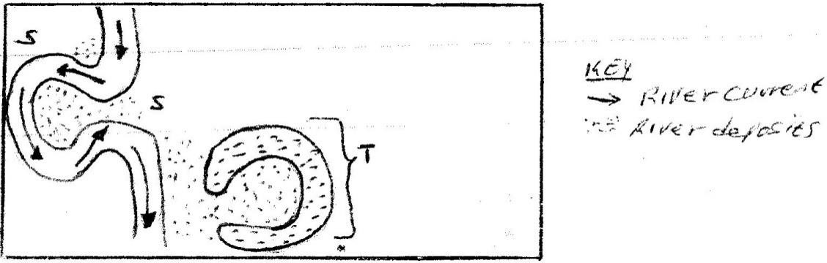

(i)Identify the feature marked T (1mark)
- Ox bow lake
(ii) State three conditions that leads to the formation of the feature Identified in b(i) (3marks)
- Presence of pronounced meanders in the flood plain.
- Heavy load being carried by the river.
- A reduction in the river gradient/ low river velocity.
- Lateral erosion on the outer side of the river banks.
- Deposition on the inner side of the river banks.
- Periodic flooding to cut off neck of pronounced meanders.
c) Give four factors that facilitate river deposition (4marks)
- Reduction in river gradient/ decrease in velocity of river water leads to river deposition.
- Freezing of river water leads to embedments of the load in the ice leading to deposition.
- River entering a large/ calm waterbody reduces the speed of the river flow leading to river deposition.
- Presence of obstacles on the river course which blocks some of the load leading to river deposition.
- Reduction in river volume which reduces the strength of the river hence deposition.
- Increase in the width of the river channel makes water to spread over wide area leading to river deposition.
- Increase in the amount/ size of the load in the river channel leads to collision within leading to deposition.

d).Geography students from Baraka School carried out a field study in the old stage of a river
(i)State three ways they could have used to collect data (3marks)
- Direct observation
- taking photographs
- Conducting interviews
- Administering questionnaire

(ii)Name three features they could have observed (3marks)
- Alluvial fans
- Meanders
- ox bow lakes
- Braided river channels
- Natural levees
- deferred tributaries
- Flood plains
- Deltas and distributaries.
10. a)(i)Define the term glaciation. (2 marks)
- Glaciation is the action of moving ice on the surface of the earth/process by which landscape is sculptured by the action of moving ice.
(ii) Name three ways in which ice moves outwards from its area of accumulation. (3 marks)
- Plastic flowage
- Basal slip
- Extrusion flow
(b).State three factors that influence glacial erosion. (3 marks)
- Well jointed/faulted rocks are easily eroded by plucking since the joints allow water to enter the rock/Less resistant rocks are eroded faster by abrasion compared to more resistant rocks.
- The more the debris embedded in the glacier the more effective is abrasion process.
- The steeper the slope, faster the speed of the glacier and the greater the erosive energy.
- a thick glacier exerts great pressure on the underlying rock causing weathering. The rock debris embedded in the glacier is pressed down by the thick glacier to erode by abrasion.
c).The diagram below shows some features of glaciation erosion. Use it to answer the questions that follow.
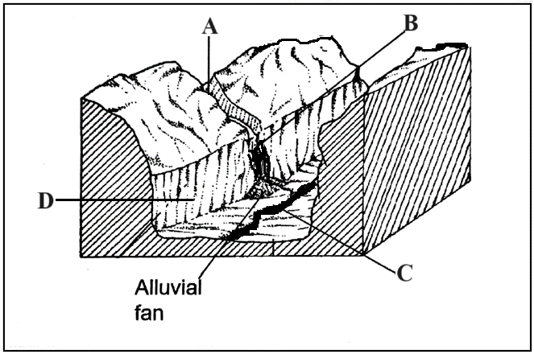
(i)Name the parts labeled A, B and C. (3 marks)
A – Hanging valley
B – Waterfall
C – River
(ii)Describe how the part labeled D is formed. (5 marks)
- A pre-existing river valley is filled with ice/glacier
- As glacier moves downstream, tributary glaciers increase the amount of ice in the main valley
- Glacier erodes the main valley by plucking and abrasion
- The interlocking spurs in the main valley are trimmed into truncated spurs.
- Continued glacial erosion deepens, widens and straightens the main valley floor forming a U-shaped valley or a glacial trough

d (i) List three depositional features of glaciation in lowland areas. (3 marks)
- Kames and eskers
- Erratics
- Boulder trains
- Outwash plains
- Drumlins
- Terminal moraines 3×1mk=3mks

ii) Explain three negative effects of glaciation on the human environment. (6 marks)
- The boulder clay deposited creates marshy landscape due to poor drainage making it unsuitable for human settlement.
- The infertile soil deposited makes it unsuitable for agriculture.
- The numerous lakes formed in the lowlands reduces the land available for use.
- Glaciation results into rugged landscape making construction of transport networks/ settlement/ agriculture difficult.
- Glacial deposits may bury minerals making mining difficult/ expensive.
- Avalanches may lead to destruction of property/ loss of life.

